1. Create a News Room Page Component using the Base Page Component

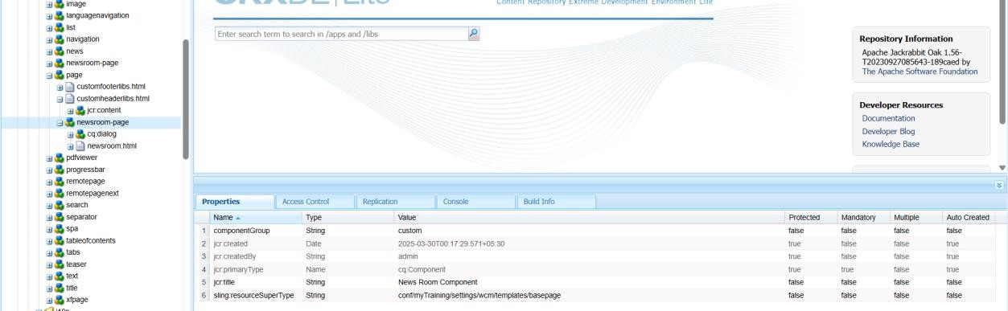

1. Create Custom Page Property: "NEWS Configurations"
2. Add "Read More" CTA for News Articles

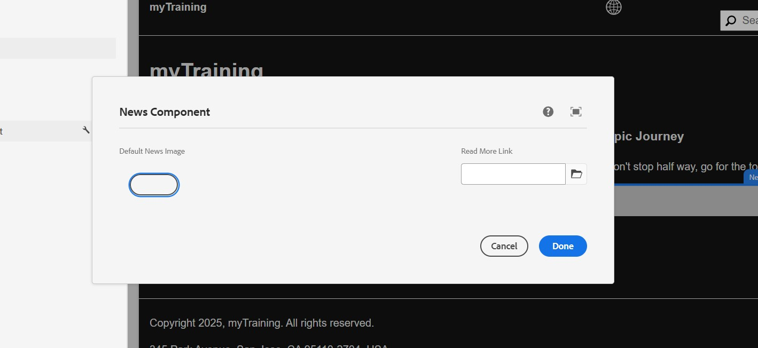

1. Create News Room Template Type using News Room Page Component

Steps to Implement:

* + Go to AEM > Tools > General > Template Types.
  + Create a new Template Type named News Room Template Type.
  + Set the Allowed Resource Type as your-project/components/page/newsroompage.

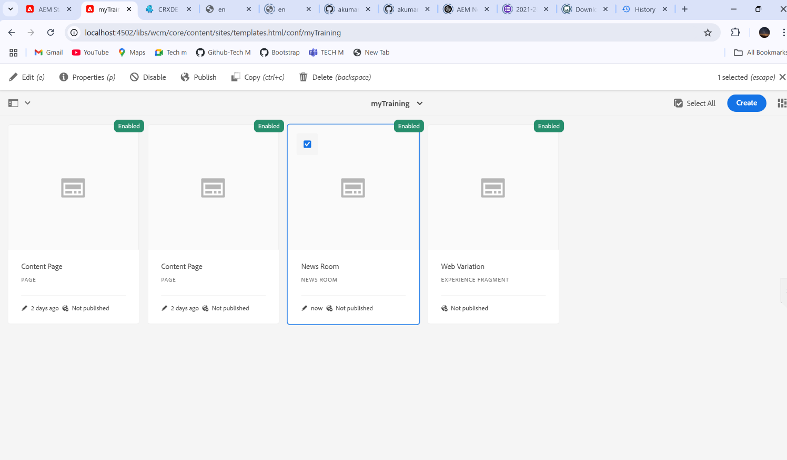

How to Verify:

* + Go to Template Editor and check if the template type appears.
  + Try creating a template using this type.

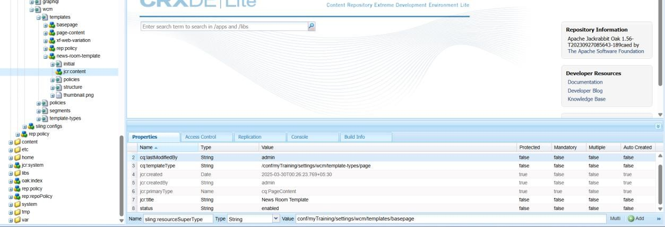

1. Create News Room Template using News Room Template Type

Steps to Implement:

* + In AEM > Templates, create a new template using News Room Template Type.
  + Define the structure (Header, News Listing, Footer, etc.).

How to Verify:

* + Check if the template appears under Templates in AEM.
  + Create a page using this template and verify the structure.

